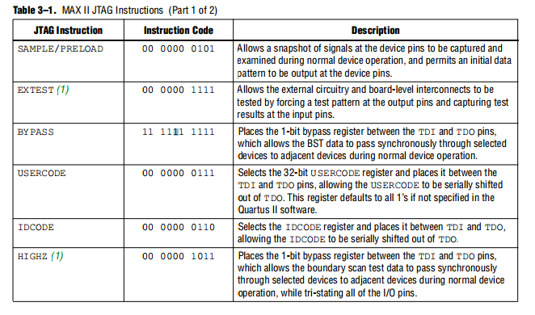

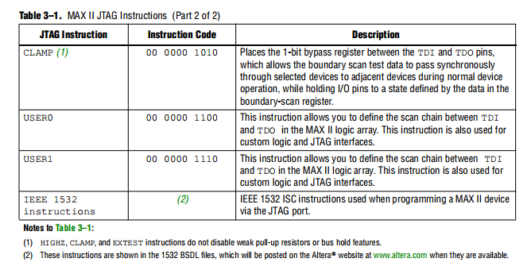

# Sample/Preload Instruction Mode

The SAMPLE/PRELOAD instruction mode allows you to take a snapshot of device data without interrupting normal device operation. However, this instruction mode is most often used to preload the test data into the update registers prior to loading the EXTEST instruction. Figure 13–8 shows the capture, shift, and update phases of the SAMPLE/PRELOAD mode.

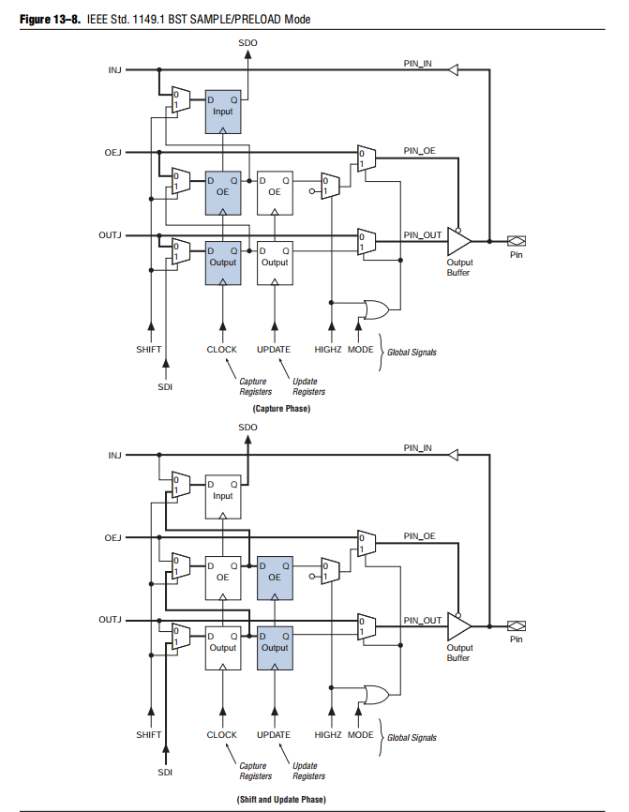

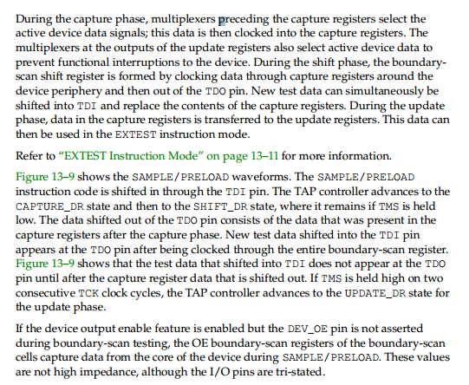

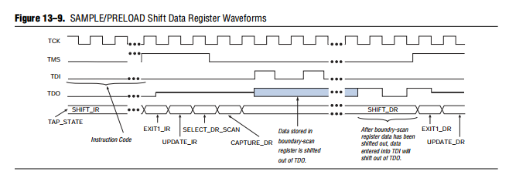

# EXTEST Instruction Mode

The EXTEST instruction mode is used primarily to check external pin connections between devices. Unlike the SAMPLE/PRELOAD mode, EXTEST allows test data to be forced onto the pin signals. By forcing known logic high and low levels on output pins, opens and shorts can be detected at pins of any device in the scan chain. Figure 13–10 shows the capture, shift, and update phases of the EXTEST mode.

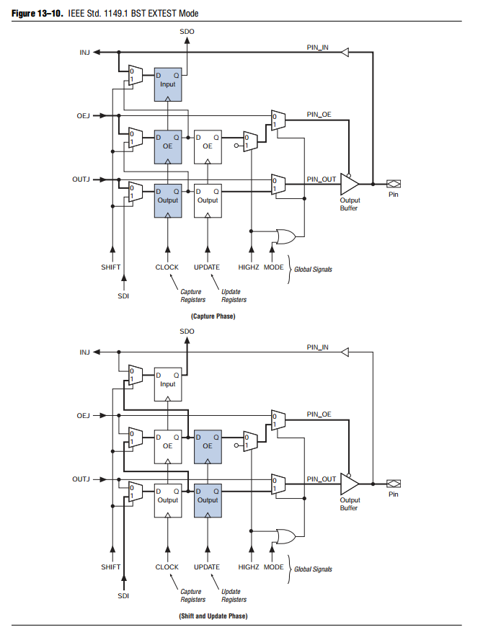

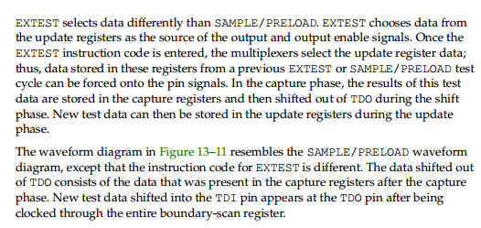

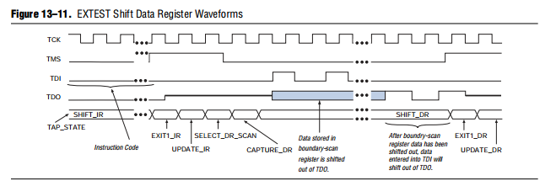

# BYPASS Instruction Mode

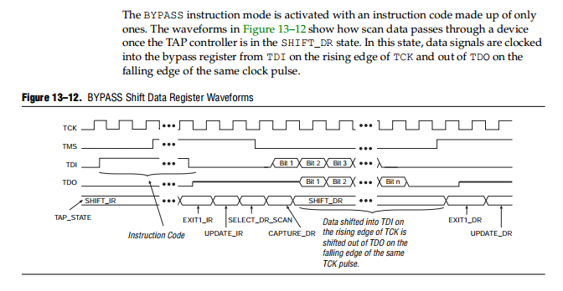

# IDCODE Instruction Mode

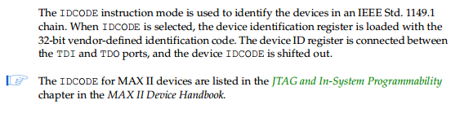

# USERCODE Instruction Mode

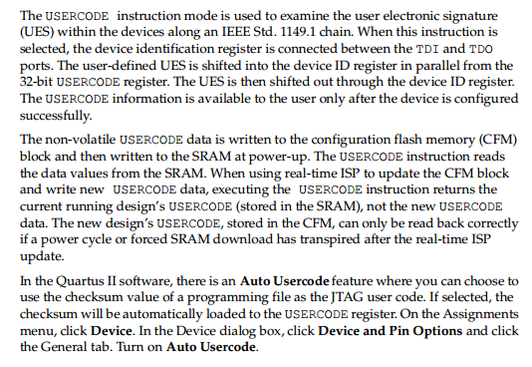

# CLAMP Instruction Mode

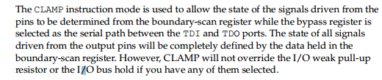

# HIGHZ Instruction Mode

